2.31: a) At t = 3 s the graph is horizontal and the acceleration is 0. From t = 5 s to t = 9 s, the acceleration is constant (from the graph) and equal to 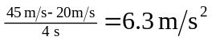. From t = 9 s to t = 13 s the acceleration is constant and equal to
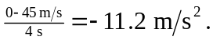
b) In the first five seconds, the area under the graph is the area of the rectangle, (20 m)(5 s) = 100 m. Between t = 5 s and t = 9 s, the area under the trapezoid is (1/2)(45 m/s + 20 m/s)(4 s) = 130 m (compare to Eq. (2.14)), and so the total distance in the first 9 s is 230 m. Between t = 9 s and t = 13 s, the area under the triangle is 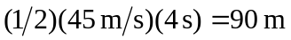, and so the total distance in the first 13 s is 320 m.

